**SPLUNK**

**Splunk Beginner to Architect**

**Section 10: Search Head Clustering:**

1. **Overview of search head clustering:**

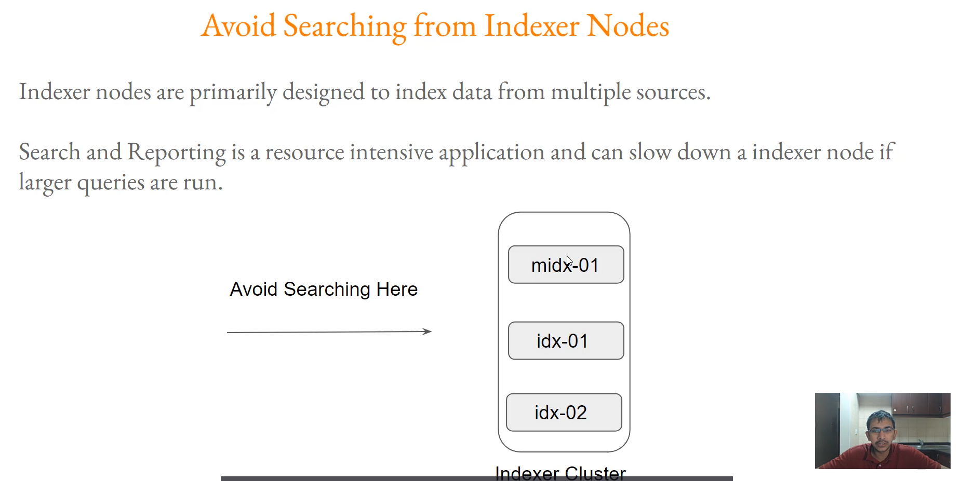

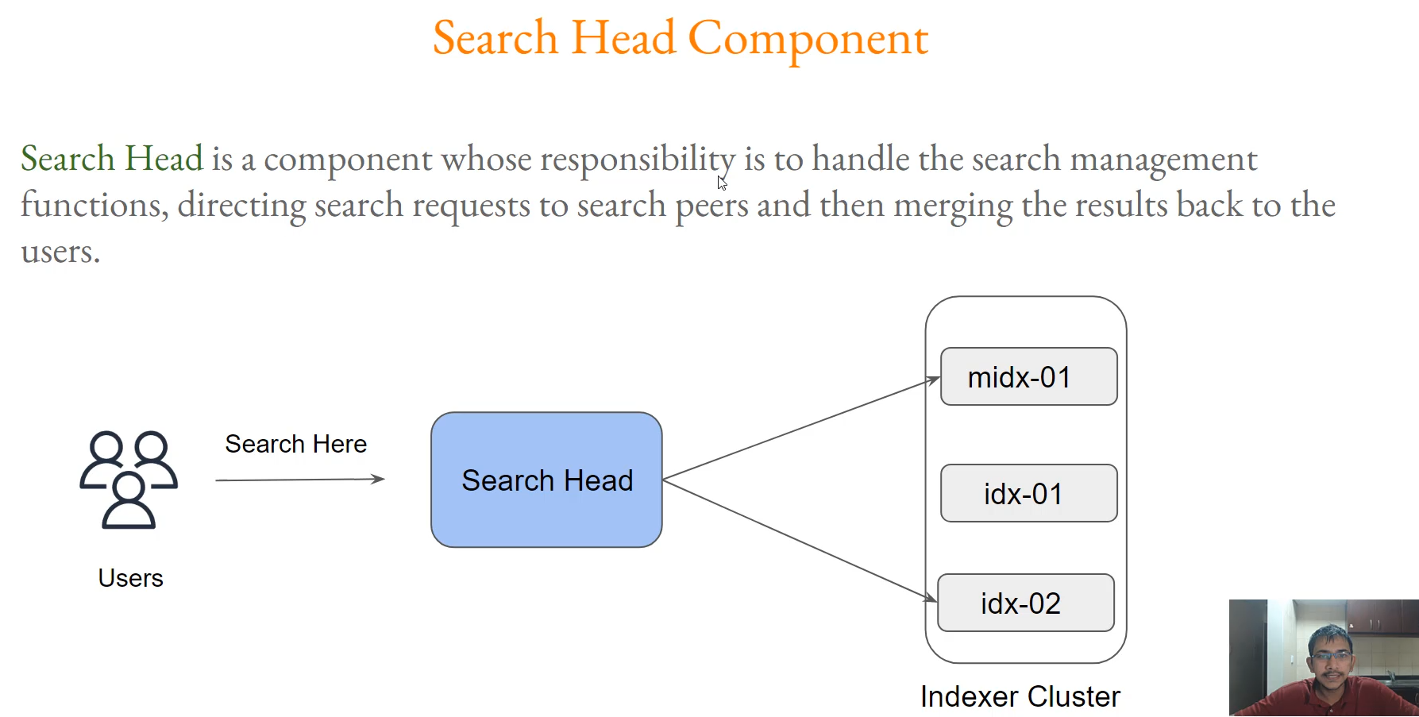

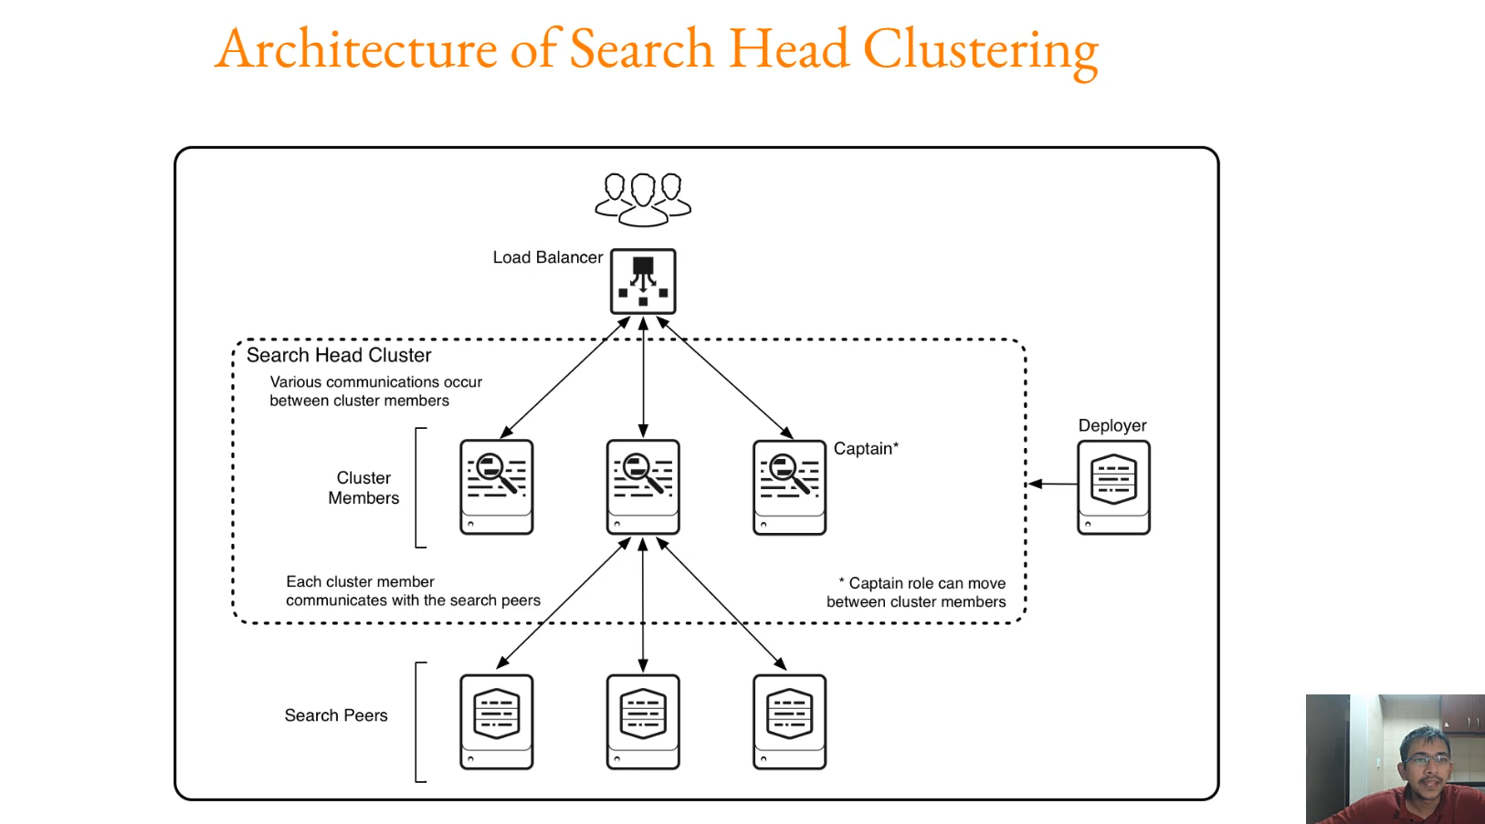

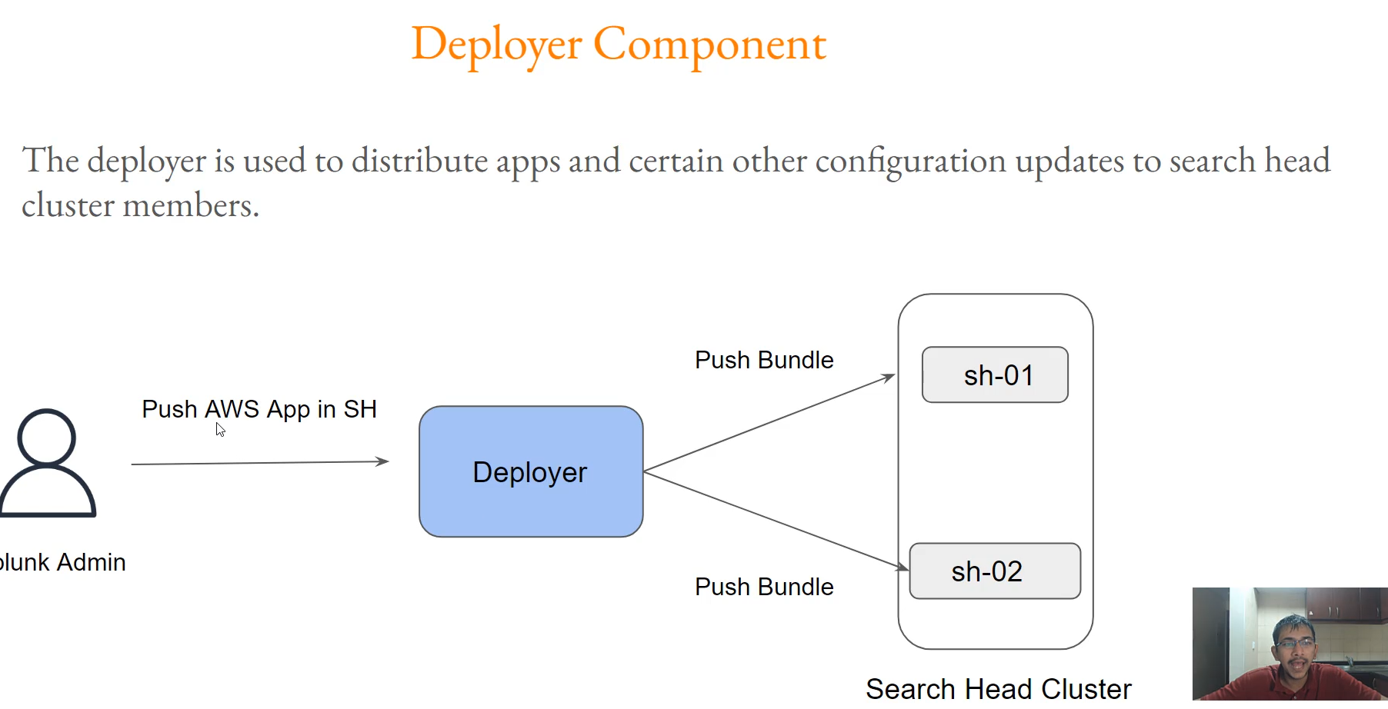

**Search Head Clustering (SHC): Overview and Components**

The core message of the video is that **Indexer nodes should focus only on indexing**, and a dedicated Search Head component is necessary to handle the resource-intensive process of searching and reporting.

**1. The Need for a Dedicated Search Head**

* **Indexer Primary Role:** Indexer nodes are primarily designed to **index data** received from thousands of Universal Forwarders (UFs).
* **The Problem with Searching on Indexers:** The Search and Reporting app is a **resource-intensive application**. Running large queries or designing dashboards directly on an Indexer node will consume significant resources, potentially **slowing down the Indexer's core function** and negatively affecting the entire Splunk environment.
* **Recommendation:** **Avoid searching data from the Indexer cluster components.**

**2. Search Head Component Responsibilities**

The dedicated Search Head component is responsible for all search management functions:

* **Handling User Logins:** All users who want to search data log into the Search Head instance.
* **Query Forwarding:** It directs user search queries to the appropriate **Search Peers** (the Indexer nodes).
* **Result Merging:** It collects the results from all Indexer peers, merges the data, and presents the final result back to the user.

**3. Search Head Clustering (SHC) Architecture**

In a production environment, a single Search Head creates a **Single Point of Failure (SPOF)**. If that one instance goes down, users cannot search data. The solution is to set up a clustered architecture for the Search Head component.

* **Cluster Members:** Multiple Splunk instances act as the **cluster members** of the Search Head Cluster (SHC).
* **Search Peers:** These cluster members connect to the **Search Peers** (which are the indexer peers where the actual data resides).
* **High Availability:** This clustered architecture ensures **high availability** for searching operations.

**4. The Role of the Deployer**

The Deployer is a mandatory component in a Search Head Cluster and handles configuration management, similar to the Master Indexer's role for the Indexer Cluster.

* **Function:** The Deployer is used to **push the configuration bundle** (apps, add-ons, lookups, dashboards) to all members of the Search Head Cluster.
* **Example:** To make an application (like the AWS App) available to all search head cluster nodes, you tell the **Deployer** to push the configuration bundle, and it distributes the app to all cluster members.

**============================================================================**

1. **Infrastructure for search head clustering:**

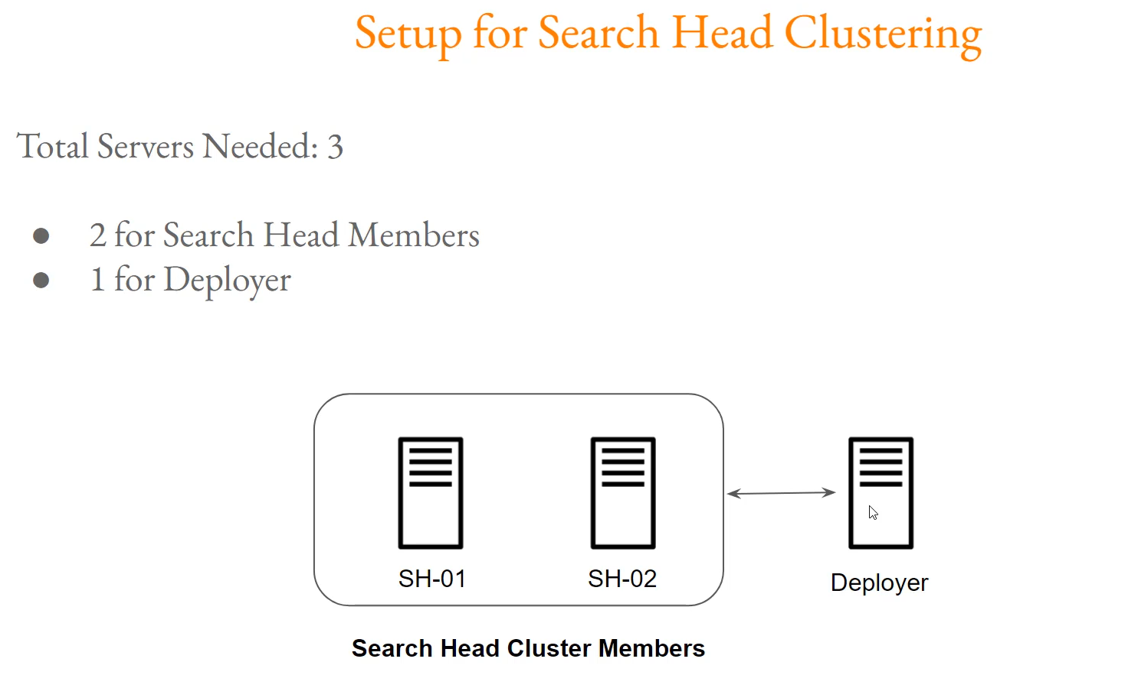

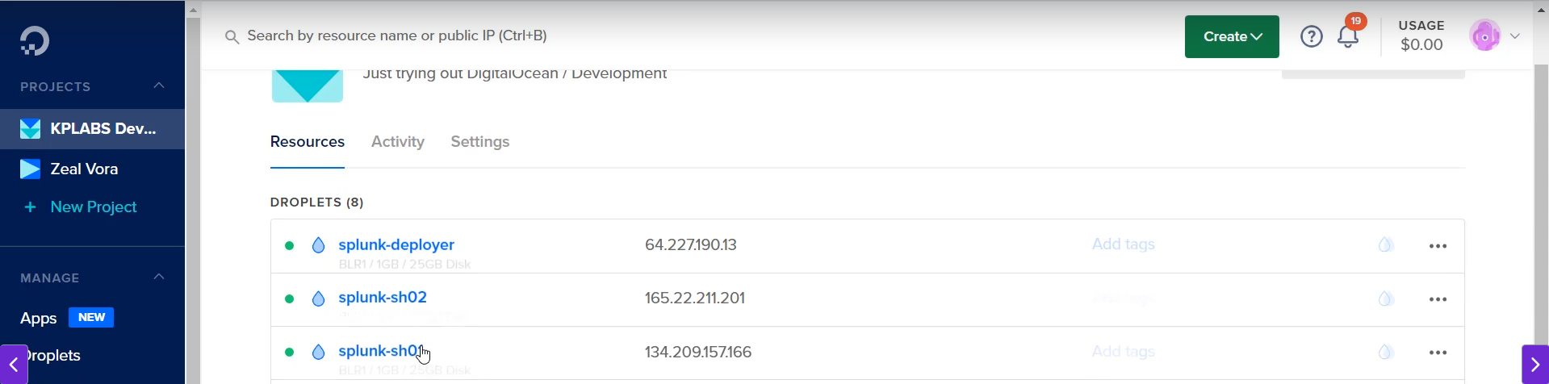

**Search Head Cluster (SHC) Infrastructure Requirements**

The practical setup for Search Head Clustering requires three dedicated servers, reflecting the core components of an SHC architecture.

**1. Required Servers (3 Total)**

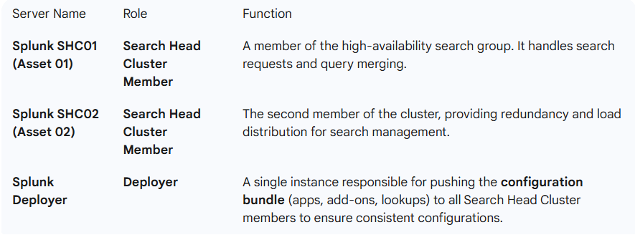

**2. Key Architectural Points**

* **Scalability:** The architecture is designed to support more than two members (e.g., seven members), with the Deployer pushing configurations to all of them.
* **Configuration Management:** The Deployer's function is analogous to the Master Indexer's role in the Indexer Cluster—it ensures all cluster members have the same necessary applications and configurations.
* **Integration:** After installing the Splunk software on these three servers, the next critical step is to **integrate the Search Head Cluster members (SHC01 and SHC02) with the existing Indexer Cluster** to allow them to fetch and search the indexed data.

**============================================================================**

1. **Setting up search head clustering:**

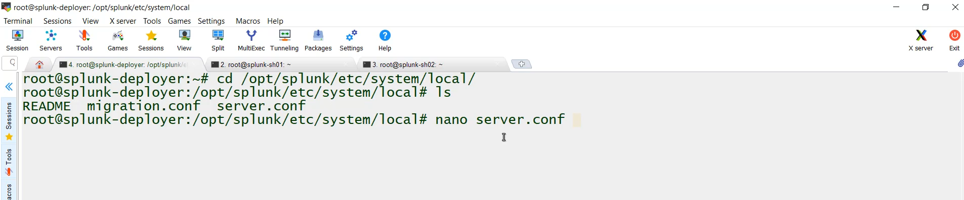

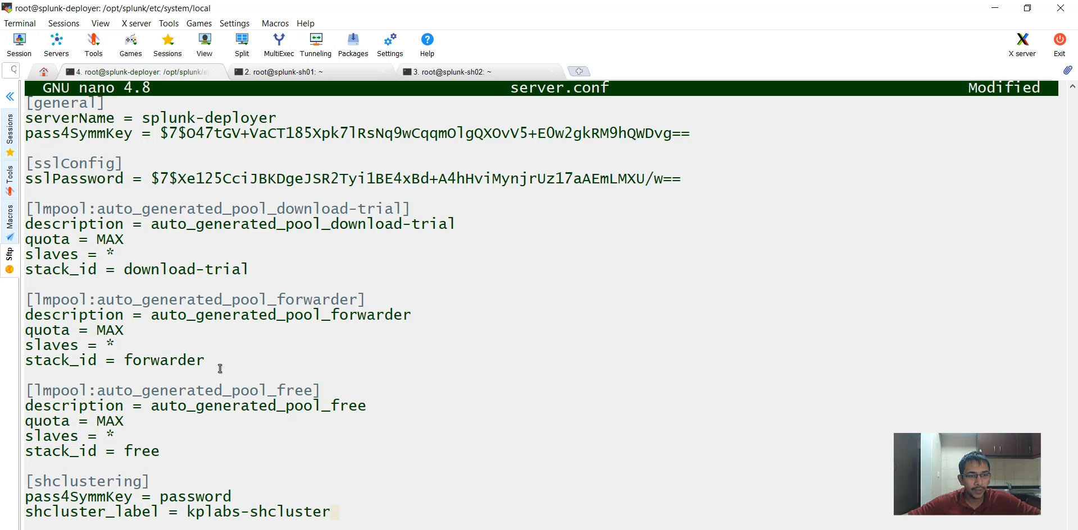

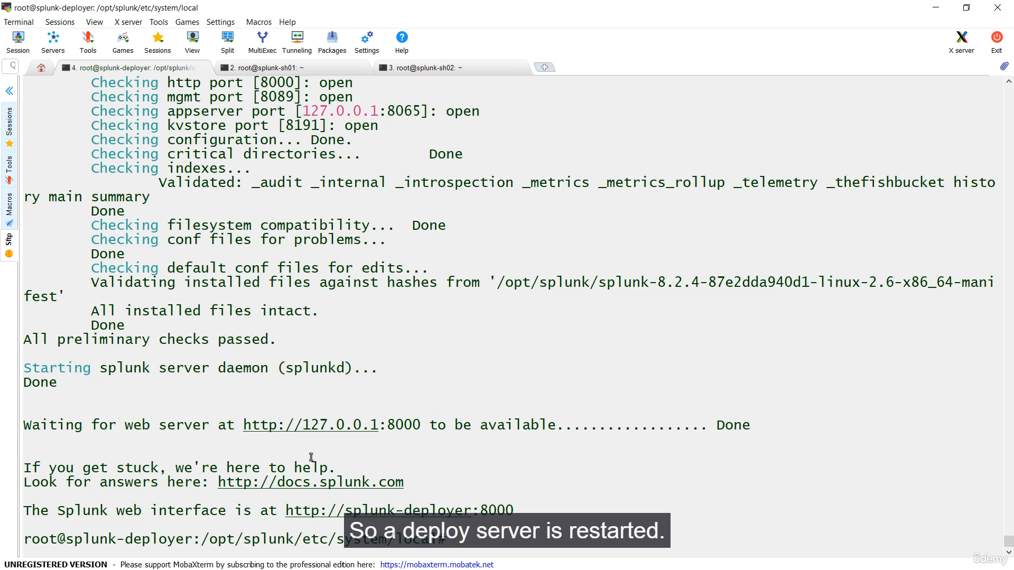

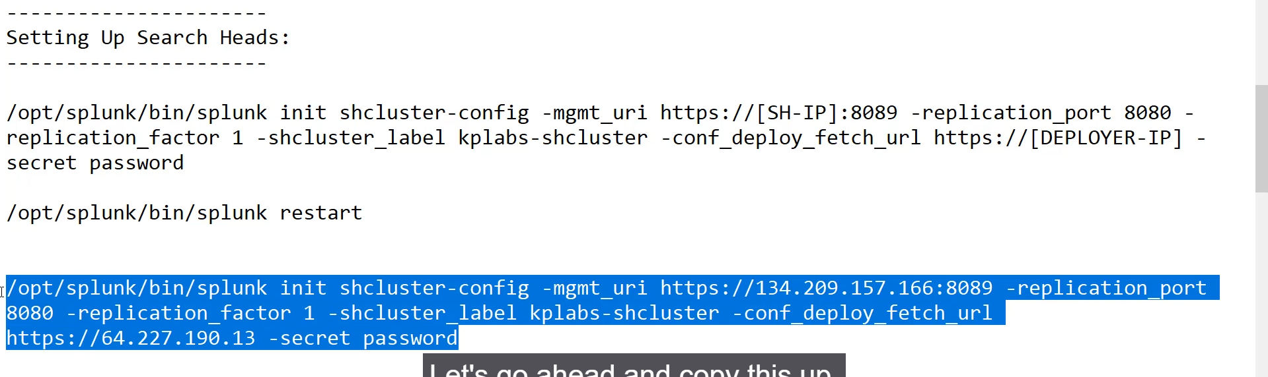

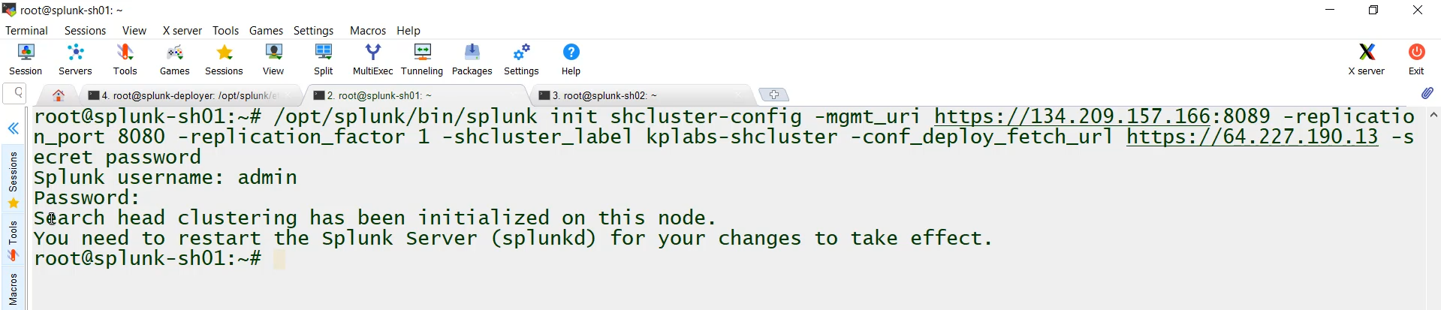

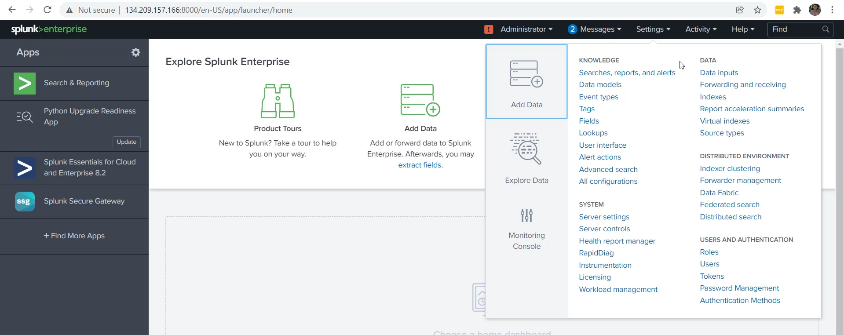

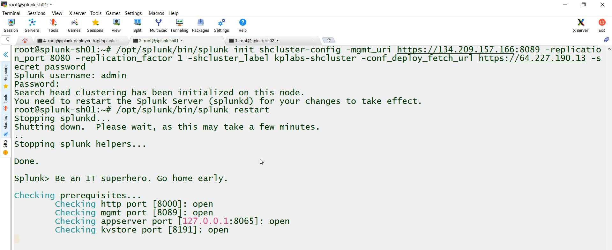

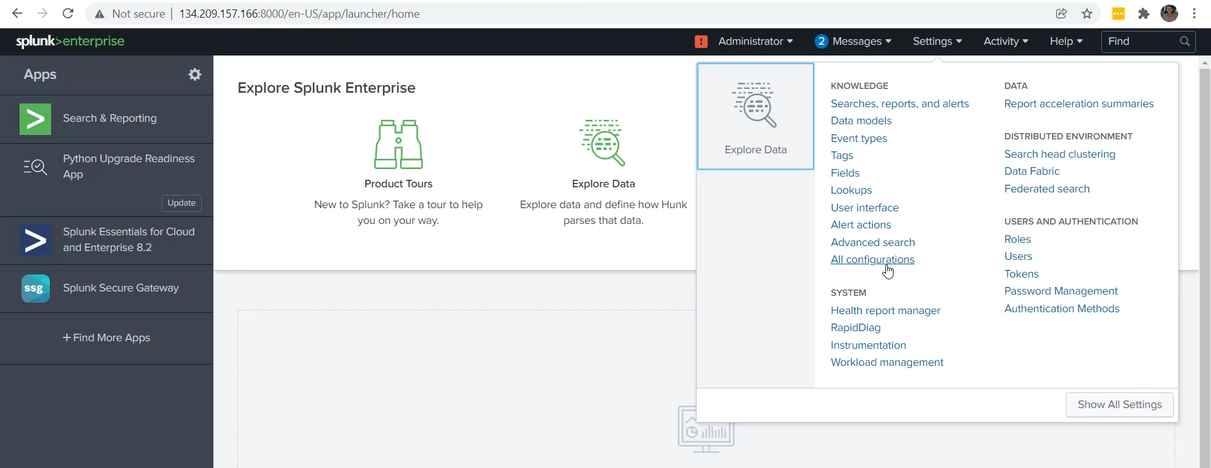

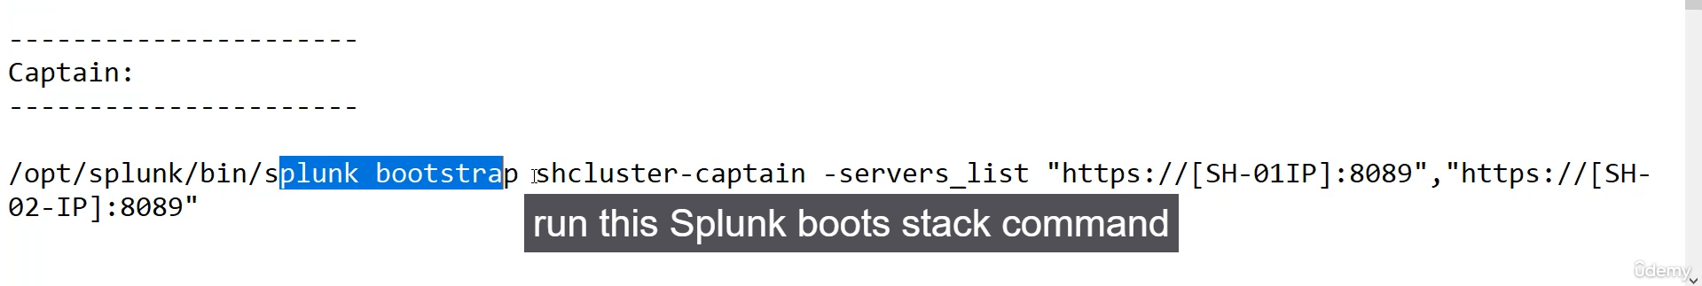

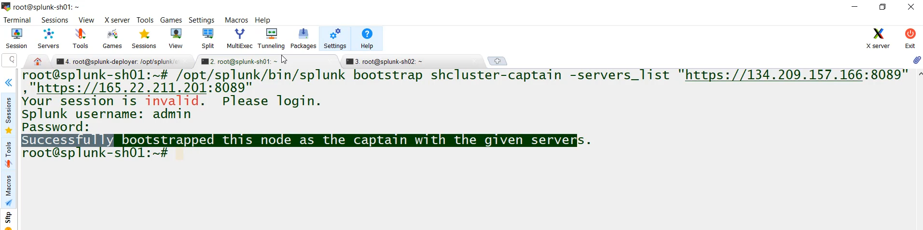

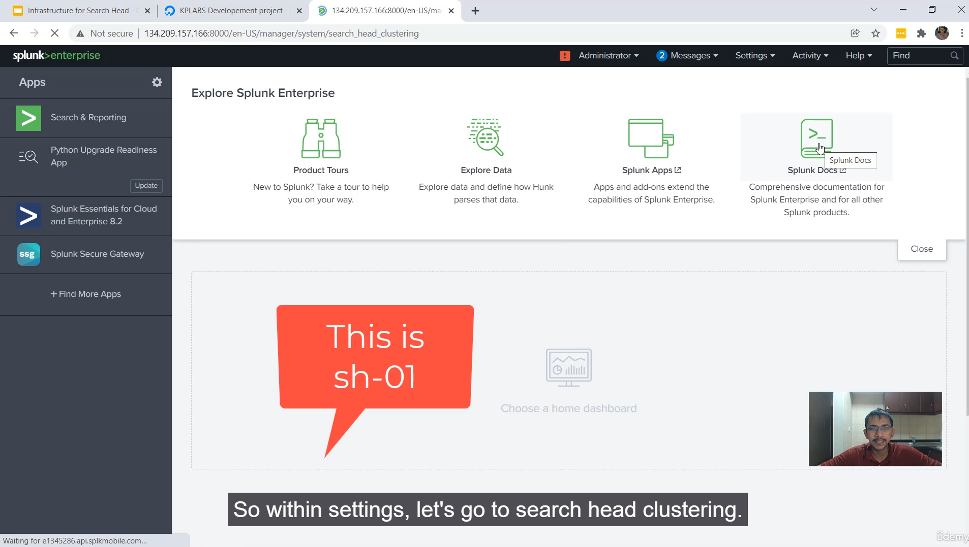

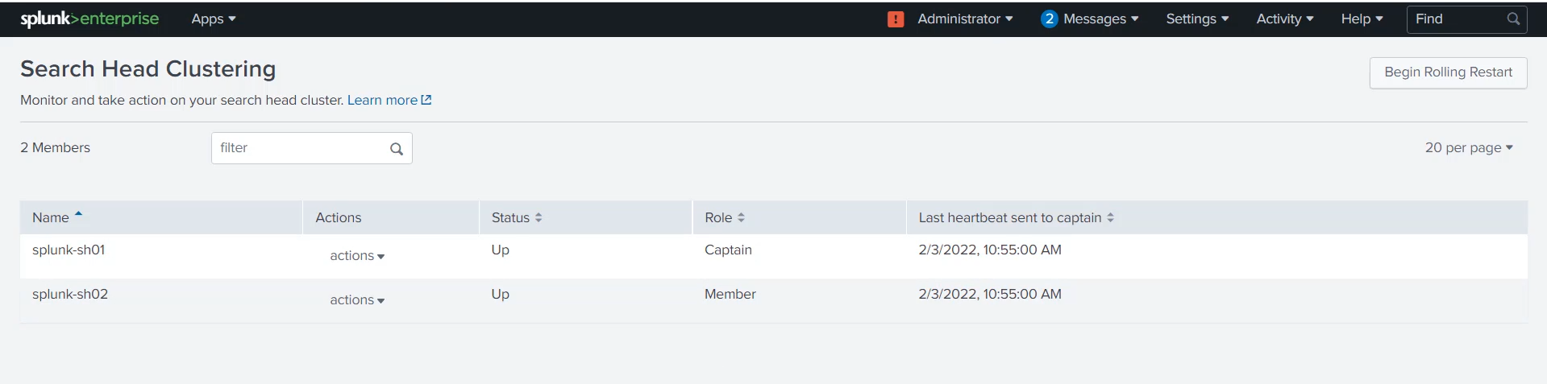

**Setting Up the Search Head Cluster (SHC) Components**

This video detailed the three main steps for initializing the SHC architecture: configuring the Deployer, initializing the cluster members, and designating the Captain.

**1. Prerequisite Infrastructure**

* **Three Servers Required:**
  1. **Splunk Deployer**
  2. **Search Head Cluster Member 1 (SHC01)**
  3. **Search Head Cluster Member 2 (SHC02)**
* **Initial Setup:** Splunk was assumed to be installed and running on all three servers (accessible on port 8000).

**2. Step 1: Configuring the Deployer**

The Deployer needs to be configured to recognize its role and set the shared secret for the cluster.

* **File:** $SPLUNK_HOME/etc/system/local/server.conf

**Stanza Added:**

[shclustering]

pass4SymmKey = mypassword (Password used to secure cluster communication)

shcluster_label = KPlabs-shcluster (A unique name/label for the cluster)

* After adding the stanza restart the splunk server (/opt/splunk/bin/splunk restart).
* **Action:** Splunk was **restarted** on the Deployer machine to apply the configuration.

**3. Step 2: Initializing Search Head Cluster Members**

Each Search Head member must be initialized using the CLI, pointing it to itself, the cluster label, and the Deployer.

* **The Command Structure (Run on each SHC member):**

/opt/splunk/bin/splunk init shcluster-config -mgmt_uri https://[SH-IP]:8089 -replication_port 8080 -replication_factor 1 -shcluster_label kplabs-shcluster -conf_deploy_fetch_url https://[DEPLOYER-IP] -secret password

* After execution of the the above command restart the splunk instance (/opt/splunk/bin/splunk restart).
* **Configuration Details for SHC01 and SHC02:**
  + <SHC_MEMBER_IP>: Replaced with the IP of the machine where the command is running.
  + <LABEL>: Used the matching KPlabs-shcluster.
  + <DEPLOYER_IP>: Used the Deployer's IP address.
  + <PASSWORD>: Used the matching mypassword.
* **Post-Initialization:**
  + The SHC members require a **restart** to finalize the change.
  + **Verification (UI):** Upon logging back into the SHC member's UI, the **Settings menu becomes restricted**, showing only options relevant to its new role as a cluster member. A new **"Search Head Clustering"** option appears in the distributed environment menu.

**4. Step 3: Bootstrapping the Captain**

A Search Head Cluster requires one member to assume the role of the **Captain**—the leader responsible for job scheduling and peer coordination. This role is dynamic but must be assigned initially.

* **The Command Structure (Run on ONE of the SHC members):**

$SPLUNK_HOME/bin/splunk bootstrap shcluster-captain \

-servers_list <SHC01_IP>:8089,<SHC02_IP>:8089,... \

-auth <username>:<password>

• **Action:** The command was run on SHC01, listing both SHC01 and SHC02 as cluster members.

• **Verification (UI):** Navigating to **Settings > Search Head Clustering** on SHC01 confirmed that both members were visible and **SHC01 was successfully designated as the Captain.**

**============================================================================**

1. **Validating search head clustering:**

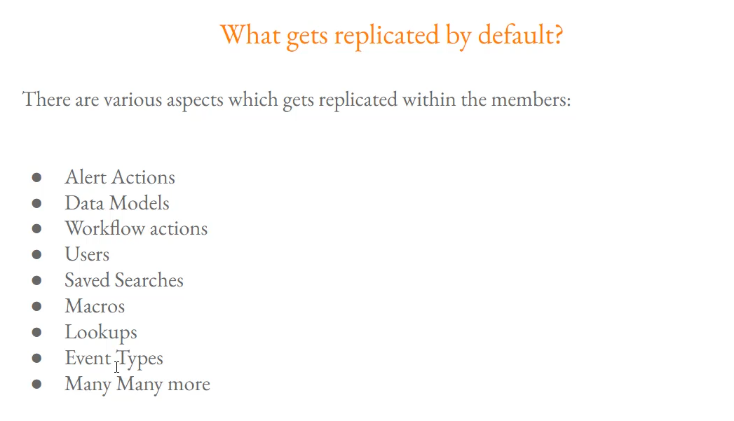

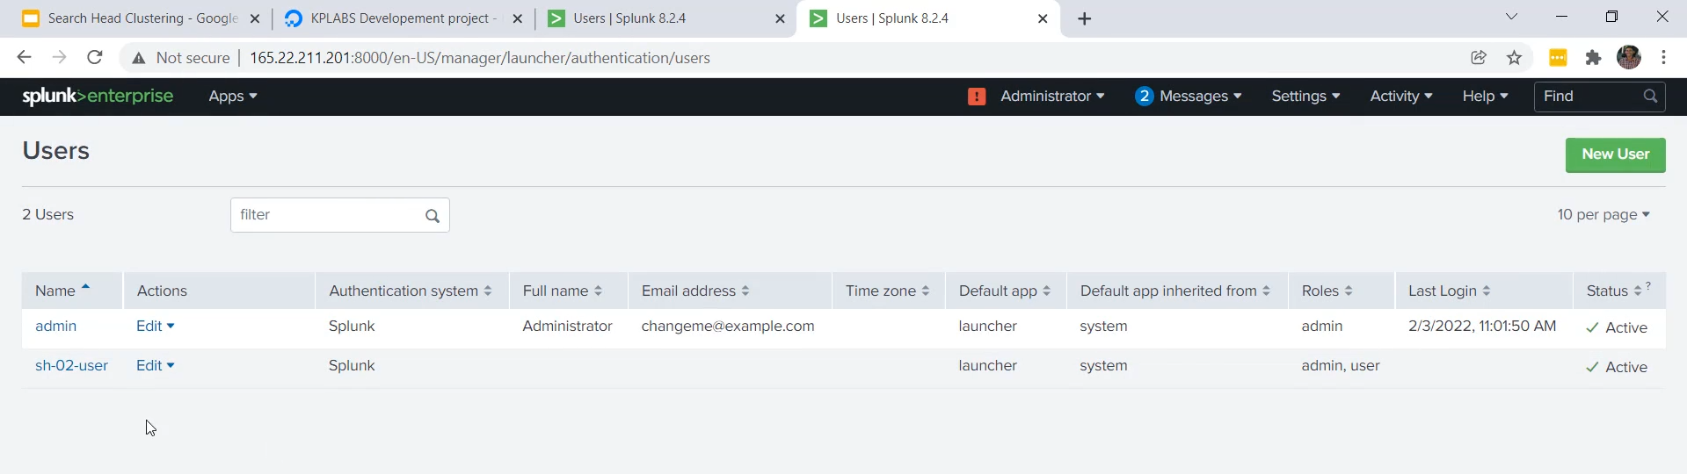

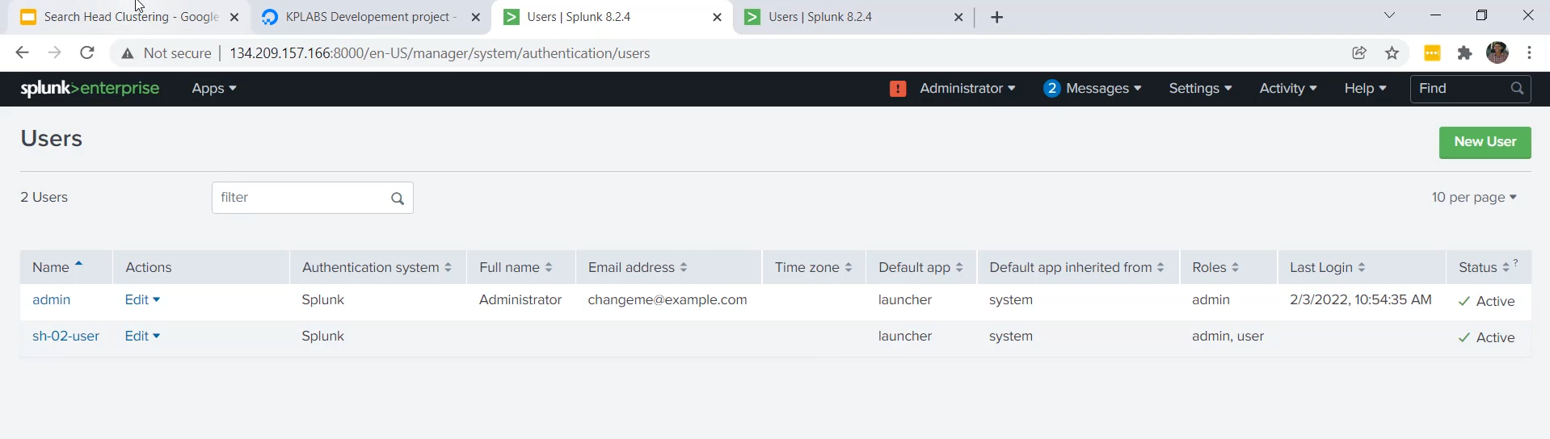

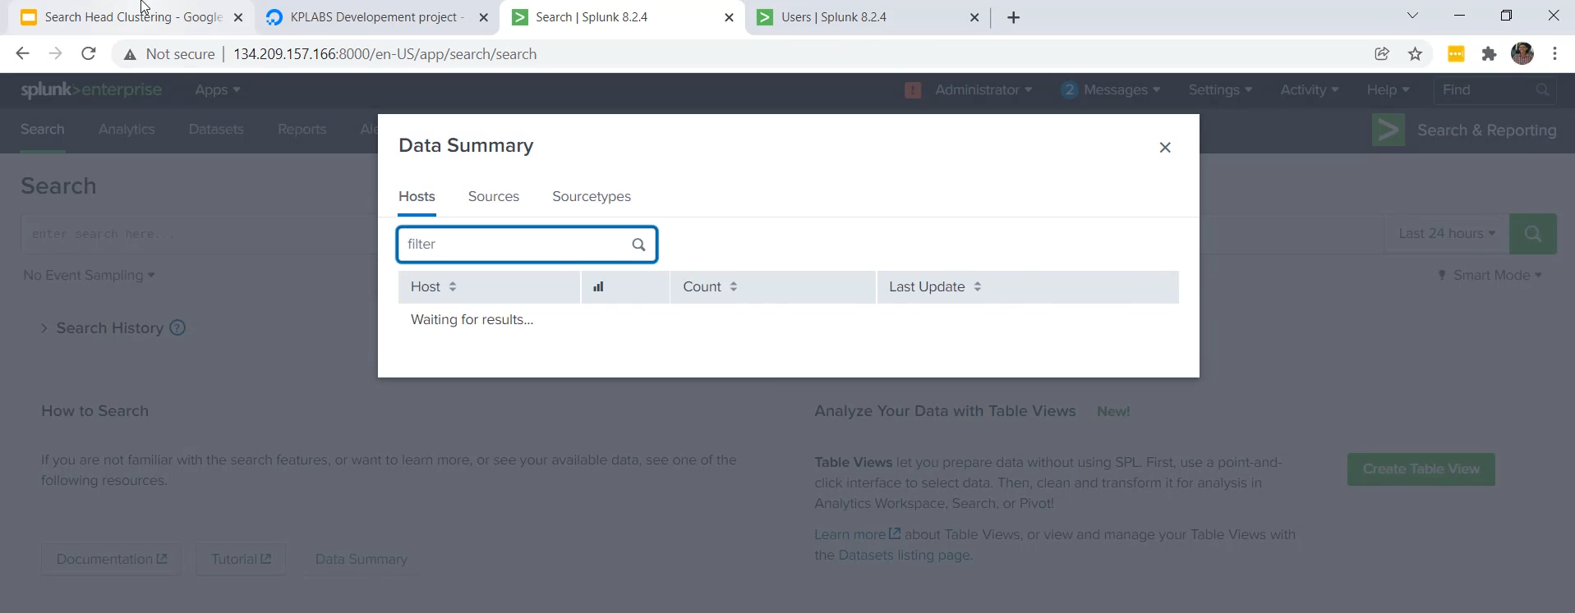

**SHC Replication and Indexer Integration Setup**

The main focus of this video was demonstrating how configuration changes and user data are automatically synchronized across all members of the Search Head Cluster (SHC).

**1. SHC Automatic Replication**

* **Core Principle:** Certain configurations and settings, when modified on one SHC member, are automatically replicated to all other members.
* **Default Replicated Items:** Essential search-related components that are synchronized include:
  + Users and Roles
  + Alert Actions
  + Data Models
  + Lookups
  + Macros
  + Event Types
  + And other search-time configurations.
* **Demonstration (User Creation):**
  1. The list of users was checked on both **SHC01** and **SHC02** (initially only showing the default user).
  2. A new user (SH_02_user) was created on **SHC02**.
  3. Upon refreshing the page on **SHC01**, the new user was immediately visible, confirming successful replication.

**2. User Access and Workflow**

* **Access Control:** Once the SHC is set up, end-users are only given login credentials for the **Search Head Cluster members**.
* **Security Principle:** Users are **not given access** to the Indexer machines, Master Indexer, or Deployer machines.
* **User Workflow:** Users log into any available SHC member and perform all their searching and reporting tasks there. Because user details are replicated, they can log into any member with the same credentials.

**3. The Next Critical Step: Connecting to Indexers**

* **Current State:** The search head members are currently **not connected** to any data source. The Data Summary page is empty because the data resides only on the Indexer Peer machines.
* **Goal:** To allow users to see and search the data, the SHC members must be configured to connect to and fetch data from the Indexer Peers (Search Peers).
* **Future Action:** The next video will cover setting up the connection between the Indexer Peers and the Search Head Cluster members to complete the full distributed architecture.

**============================================================================**

1. **Pushing artifacts through deployer:**

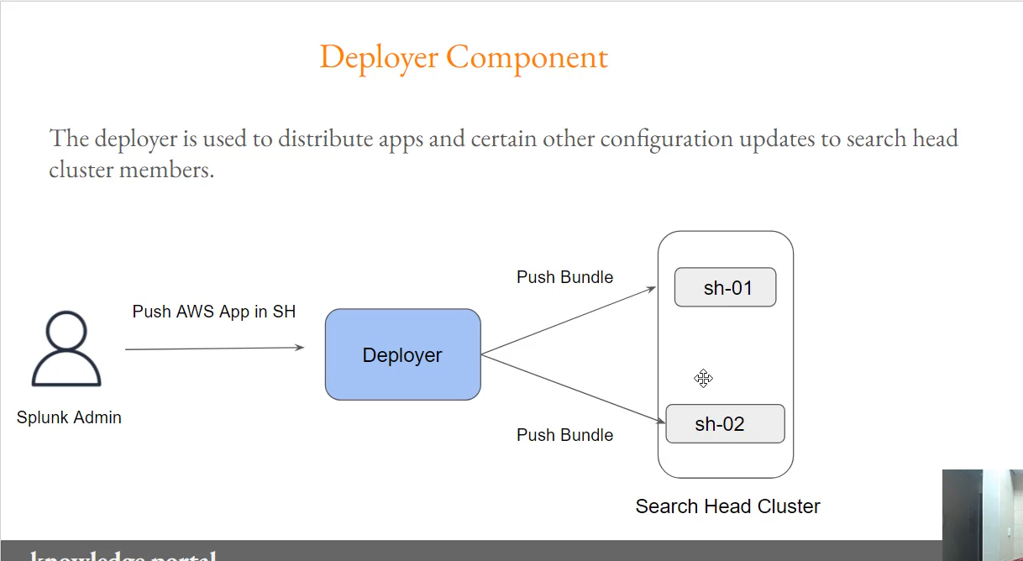

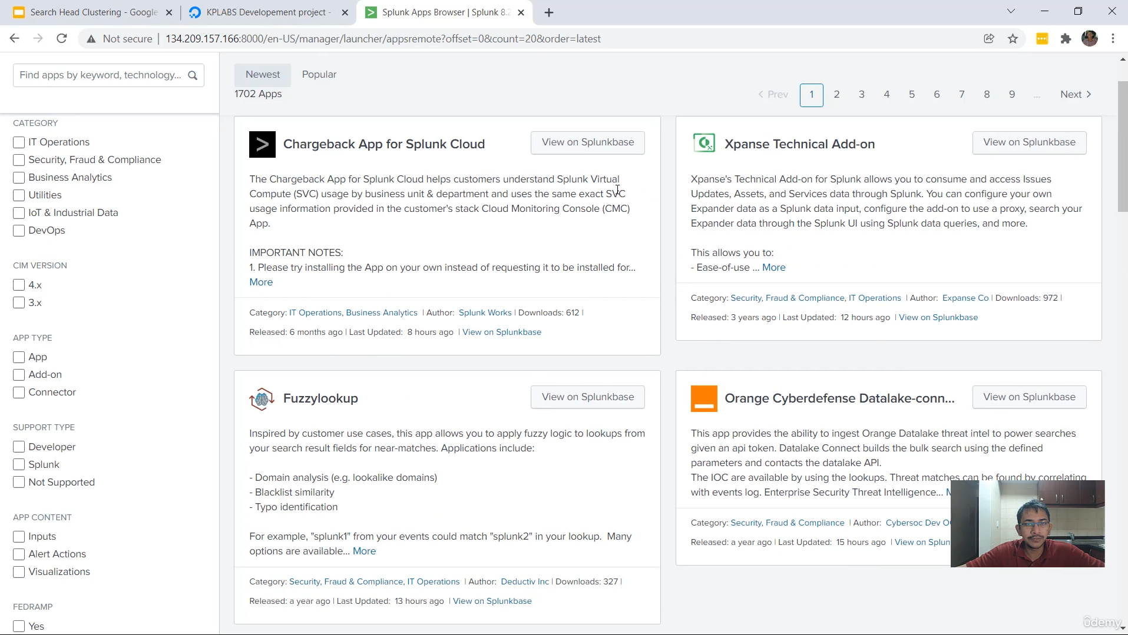

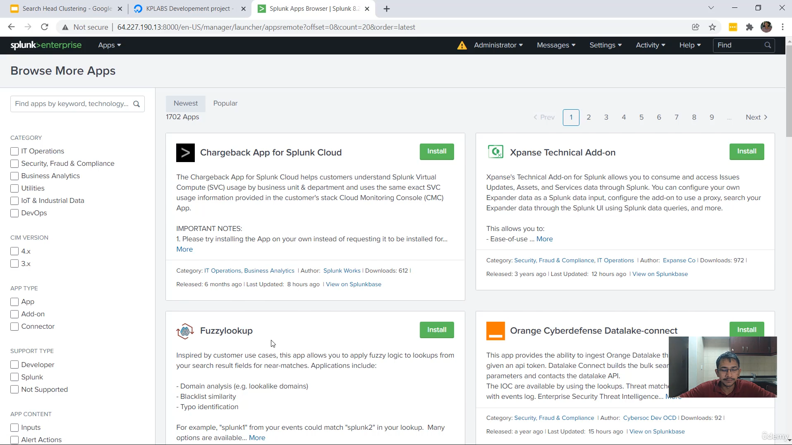

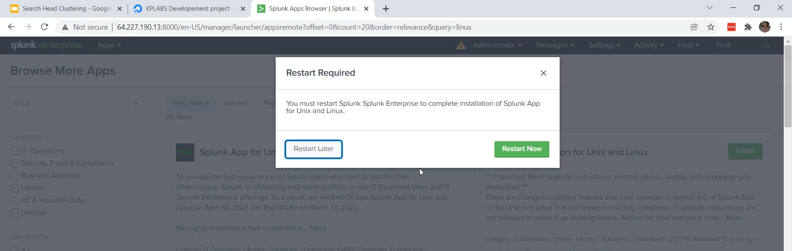

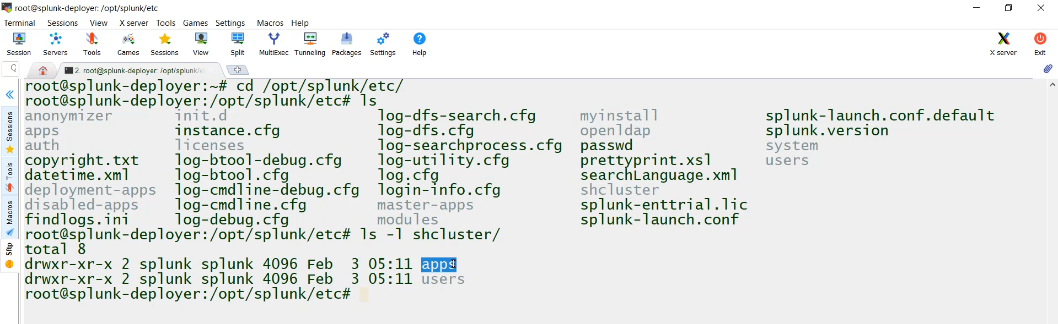

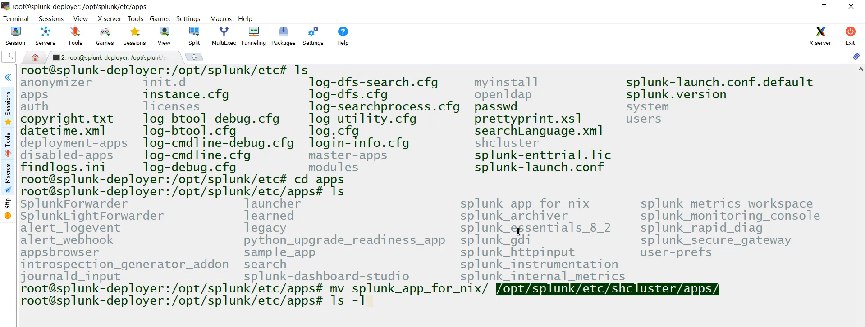

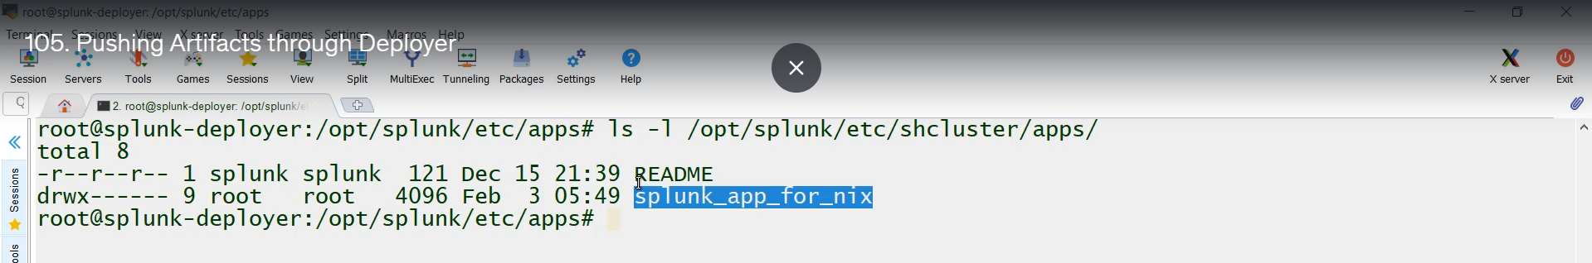

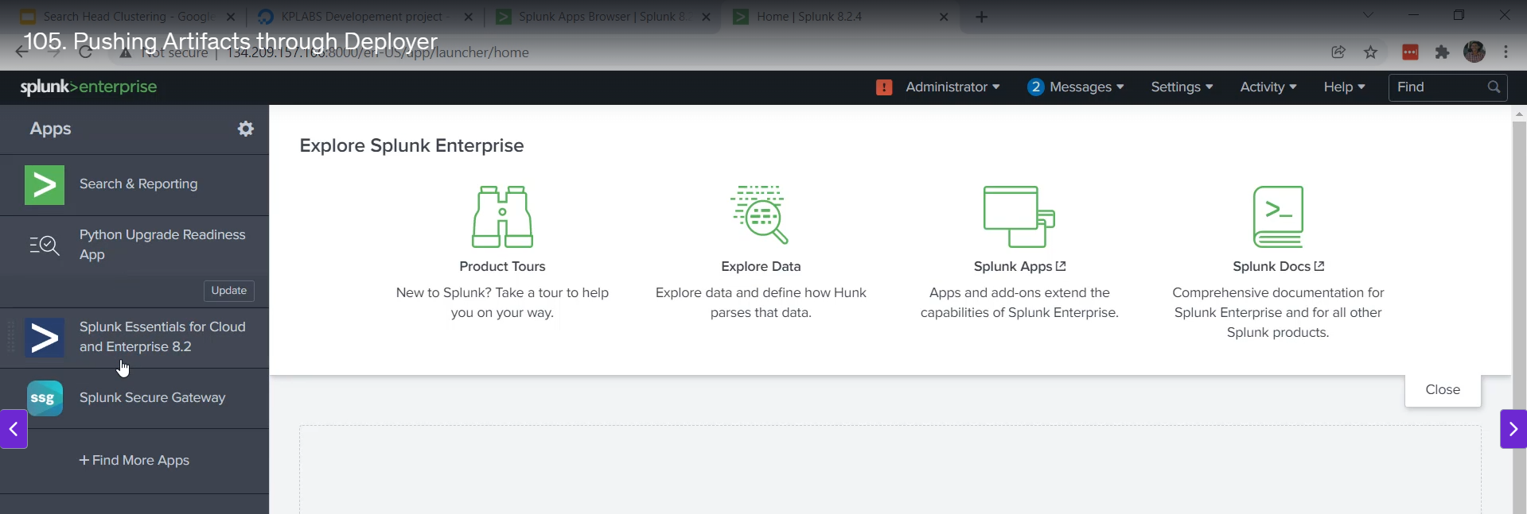

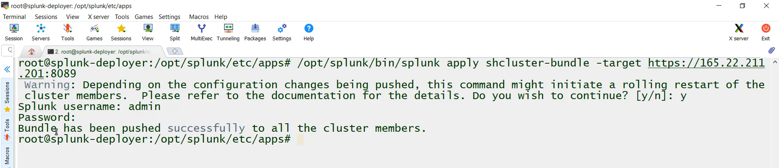

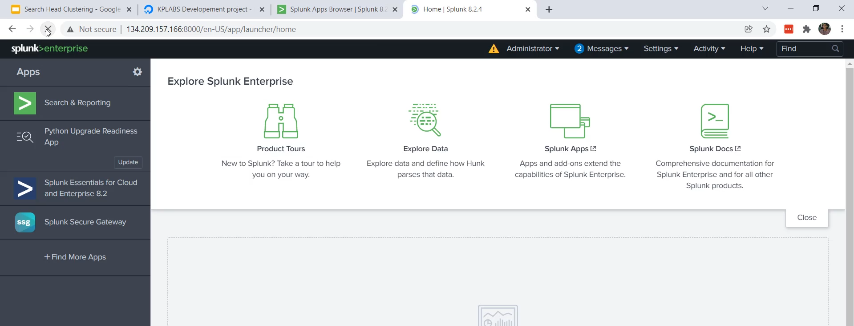

**Role of the Deployer in Search Head Clustering**

The Deployer is a dedicated Splunk instance that manages the distribution of non-replicated configurations across the Search Head Cluster members.

**1. Why the Deployer is Necessary**

* **Selective Replication:** The SHC mechanism only automatically replicates certain runtime changes (like users, saved searches, macros) made via the UI to all members.
* **Non-Replicated Items:** **Apps and Add-ons** are **not** replicated automatically. Installing an app directly on one SHC member will *not* distribute it to others.
* **UI Restriction:** To enforce this process, Splunk **disables the "Install App" option** from Splunkbase within the Search Head Cluster member's UI, forcing the administrator to use the Deployer.
* **The Solution:** All apps, add-ons, and local configuration files that need to be consistent across the entire cluster must be managed and pushed from the Deployer.

**2. Step-by-Step Deployment Process**

The demonstration covered three main steps to successfully push a configuration bundle (in this case, the Splunk App for Unix and Linux).

**A. Prepare the App on the Deployer**

1. **Install the App:** Logged into the **Deployer** machine (where the "Install App" option is available) and installed the desired app (Splunk App for Unix and Linux).
2. **Move to the Bundle Directory:** The installed app was moved from the Deployer's default app location to the Search Head Cluster bundle directory:
   * **Source:** $SPLUNK_HOME/etc/apps/<app_name>
   * **Destination:** $SPLUNK_HOME/etc/shcluster/apps/<app_name>
   * *(Note: The shcluster directory is the staging area for configurations to be pushed to the cluster members.)*

**Commands:**

cd /opt/splunk/etc/apps

mv splunk_app_for_nix/ /opt/splunk/etc/shcluster/apps/

**B. Push the Configuration Bundle**

The administrator must execute a command on the **Deployer** machine to initiate the push.

* **Command:**

/opt/splunk/bin/splunk apply shcluster-bundle -target https://[SH-IP]:8089

* + The -target argument specifies the IP address (or URI) and management port (8089) of *one* of the Search Head Cluster members. The Deployer communicates with that member, which then coordinates the distribution to the rest of the cluster.
  + The command prompts for authentication and issues a warning that a **rolling restart** of cluster members may be required, depending on the configuration changes.

**C. Verification**

1. **Execution:** After providing the credentials and confirming the prompt, the Deployer successfully pushed the bundle.
2. **Result:** Upon refreshing the Splunk Web interface on the Search Head Cluster member, the newly pushed app (**Splunk App for Unix and Linux**) was available under the Apps menu, confirming that the Deployer successfully distributed the configuration.

**============================================================================**

1. **Integration- Search head cluster to Indexer:**

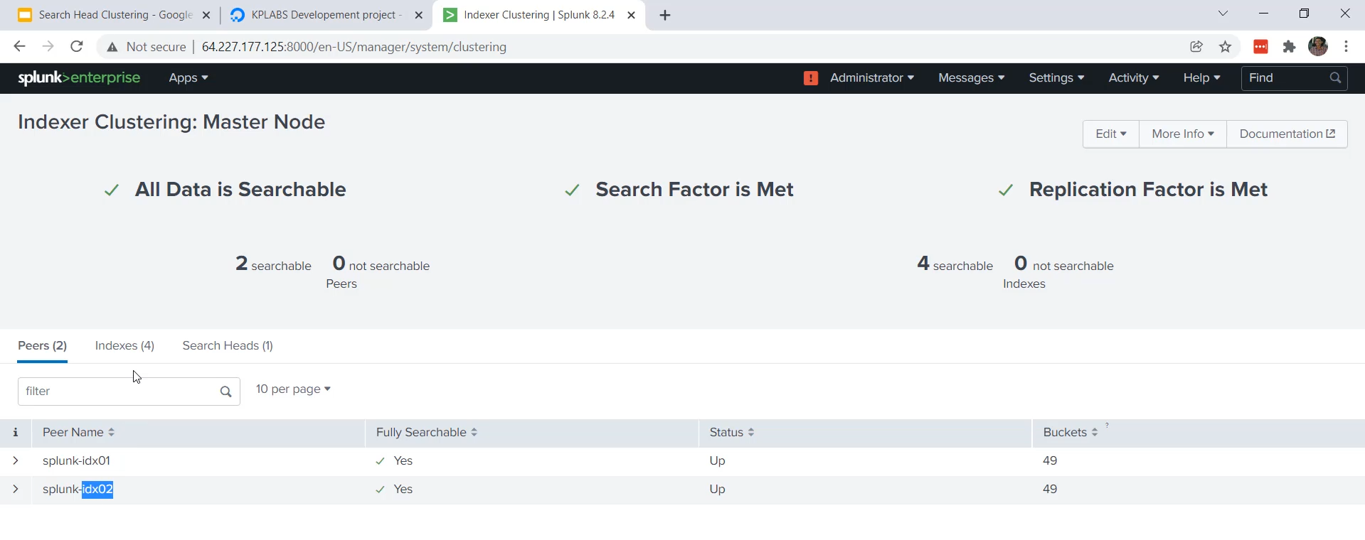

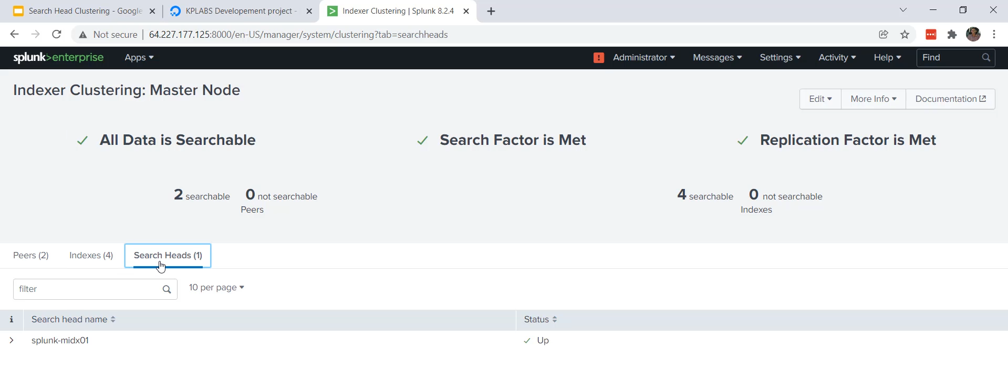

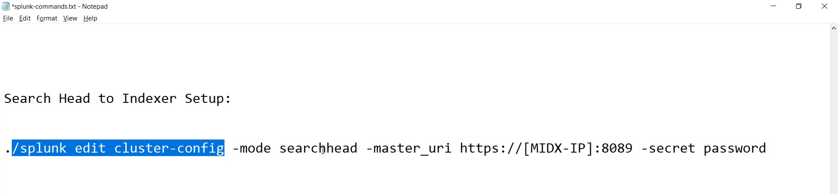

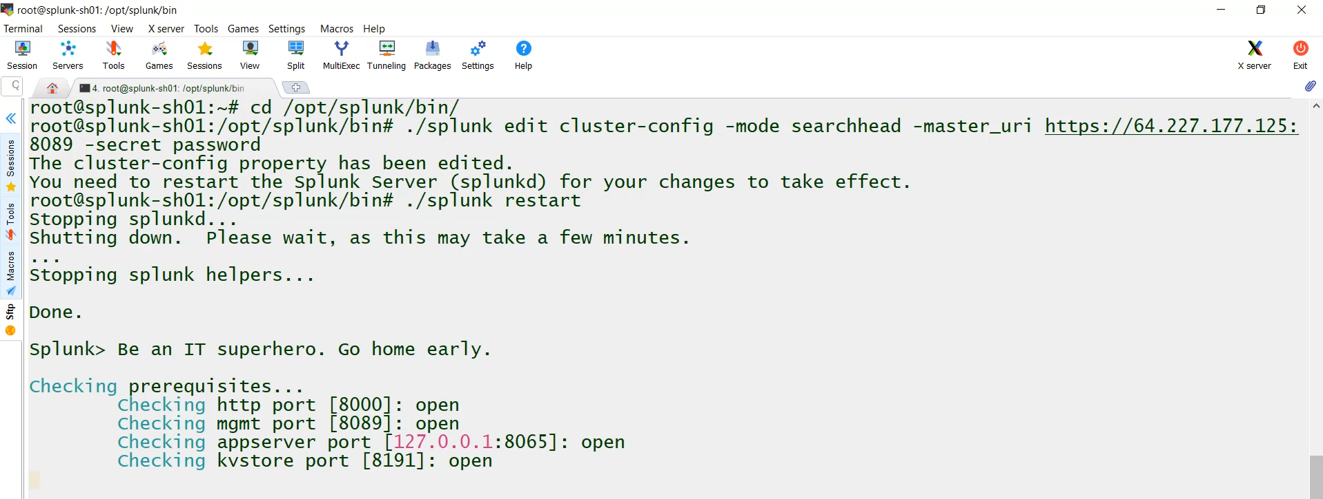

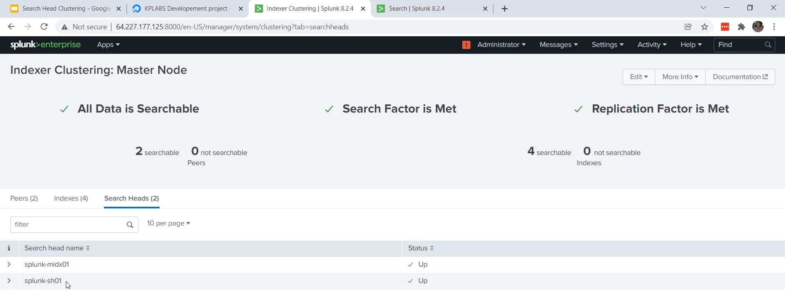

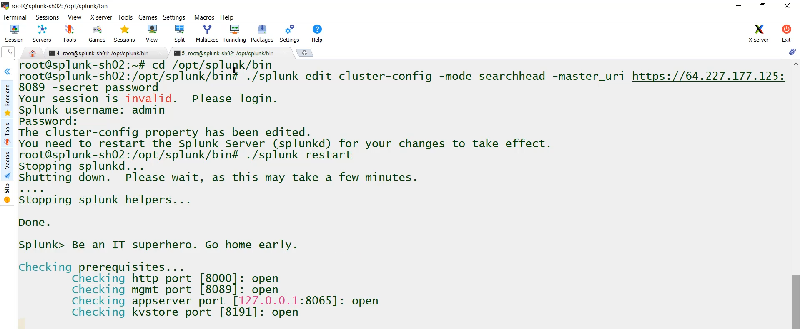

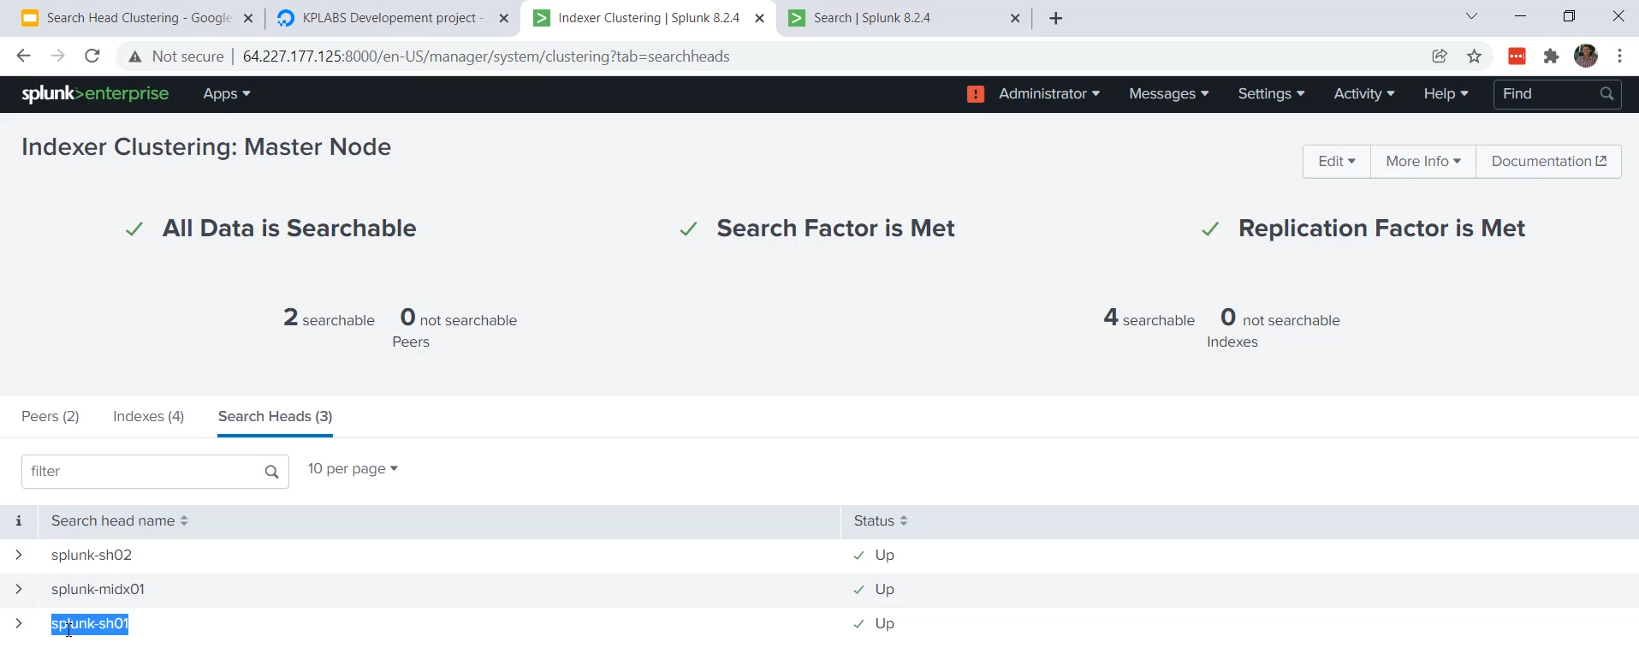

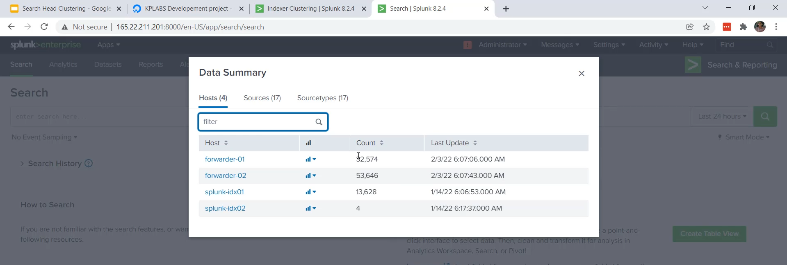

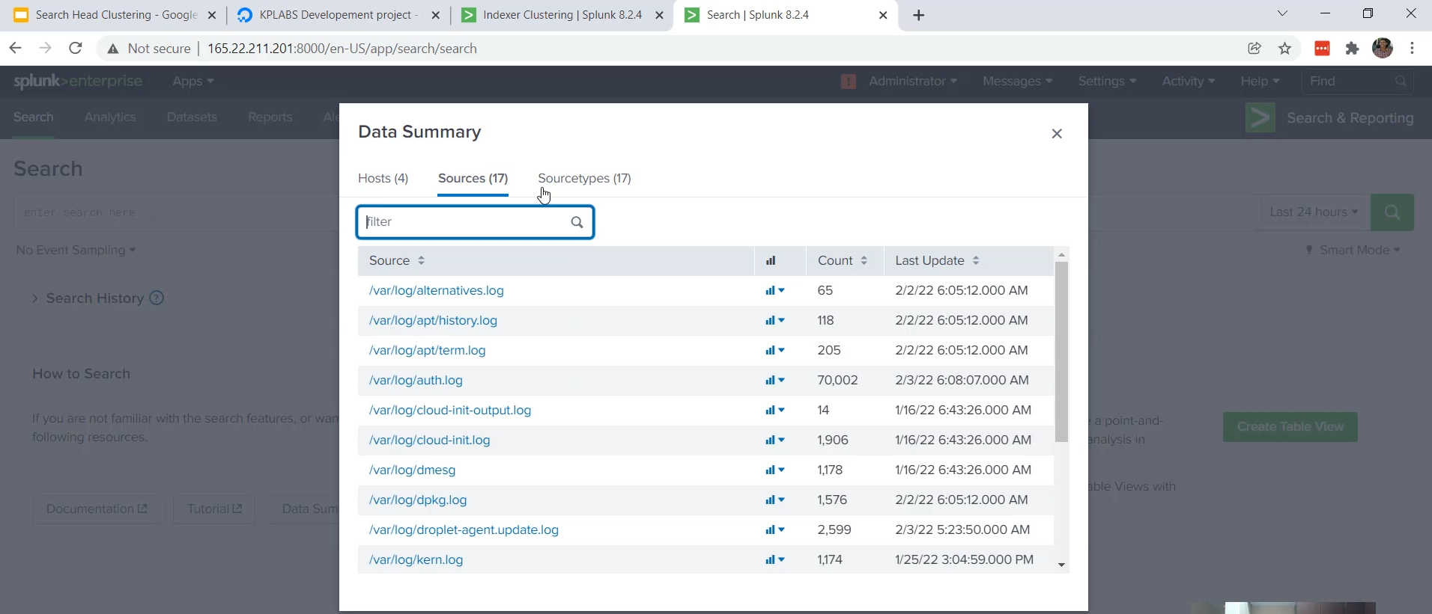

**Integrating SHC with the Indexer Cluster**

The objective of this final integration step is to allow the dedicated Search Head Cluster members to search the data residing in the Indexer Peers.

**1. Architecture Context and Goal**

* **Existing Indexer Cluster:** The setup included a Master Indexer (MIDX01) managing two Peer Indexers (IDX01 and IDX02), where all the data was stored.
* **Problem:** Currently, the MIDX01 was acting as the search head, which is discouraged. The new SHC members could not see any data.
* **Goal:** To establish a connection so that the SHC members can directly query the Indexer Peers.

**2. The Integration Command**

To connect the Search Head to the Indexer Cluster, you only need the address of the **Master Indexer**, as the Master maintains the list of all active Indexer Peers (Search Peers).

* **Command Structure (Run on each SHC member):**

$SPLUNK_HOME/bin/splunk edit cluster-config \

-mode searchhead \

-master_uri https://<MASTER_INDEXER_IP>:8089 \

-secret <PASSWORD>

**Key Parameters:**

* -mode searchhead: Specifies the role of the instance being configured (the SHC member).
* -master_uri: Provides the management port (8089) and IP of the **Master Indexer**.
* -secret: Uses the same password (password in the demo) shared for cluster communication.

**Step-by-Step Implementation**

1. **Run Command on SHC01:** The integration command was executed on the first SHC member (SHC01).
2. **Restart:** A restart was performed on SHC01, as indicated by the command output.
   * /opt/splunk/bin/splunk restart
3. **Run Command on SHC02:** The same command was executed and a restart was performed on the second SHC member (SHC02).
4. **Master Indexer Verification:**
   * On the Master Indexer, the "Search Heads" status was checked.
   * **Result:** Both Splunk SHC01 and Splunk SHC02 were successfully registered as search heads connected to the cluster.

**4. Final Verification (End-to-End Search)**

* **Action:** Logged into one of the SHC members (e.g., SHC02).
* **Result:** By going to the **Search and Reporting App** and checking the **Data Summary**, all data (including logs from forwarder01, forwarder02, etc.) was now available and searchable from the Search Head Cluster.

**5. Completed Enterprise Workflow**

With the full architecture implemented, the standard workflow is:

1. Administrators add users and manage configuration bundles on the **Search Head Cluster (SHC)** level.
2. End-users log in to the SHC members.
3. Users search the data, create alerts, and build reports directly from the SHC, which queries the centralized Indexer Cluster.

*********************************************************************************************************************************************************************************************************************************************************************************************************************